RSCDS BANFFSHIRE BRANCH
CLOTHING CATALOGUE

RSCDS BANFFSHIRE BRANCH LOGO 1 (sample)
RSCDS ‘Ladies of Banffshire LOGO 2 (sample)

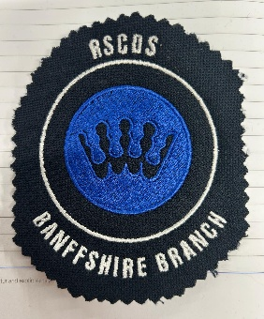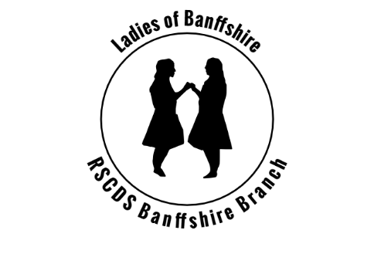

If you require further information or help regarding your order, please contact our Secretary on rscdsbanffshire@gmail.com

Men’s polo shirt - £14.99 including the logo – order reference H475
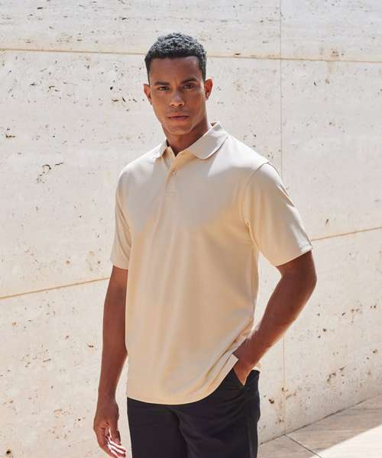
HB475: Coolplus® polo shirt
Manufacturer Code: H475
The ultimate performance polo. Stay cool and fresh in this permanent wicking polo shirt. With a wide variety of colours to choose from and its ability to perform, you can be sure this polo shirt will suit all your needs.
Fabric
100% Polyester micro piqué
Weight
180gsm
Specification
Men’s CoolPlus® wicking polo shirt. Micro piqué. Flat knit collar. Hemmed sleeves. Side vents for ease of movement. Wicking yarn for prolonged performance. Excellent colour retention. Minimum iron. Easycare.
Washing Instructions
40 synthetic. Do not bleach. Low tumble dry. 1 dot iron. Do not dry clean. Wash at 40 degrees synthetic cycle. Can be washed up to 60 degrees. Wash dark colours separately. Do not use Fabric Softner. Tumble dry Low Temperature. Cool iron on reverse.
Sizes:XXS* 32/34" XS 34/36" S 36/38" M 38/40" L 42" XL 44/46" 2XL 48" 3XL 50/52" 4XL† 54" 5XL† 56/58"
*XXS only available in these colours. †4XL and 5XL only available in these colours

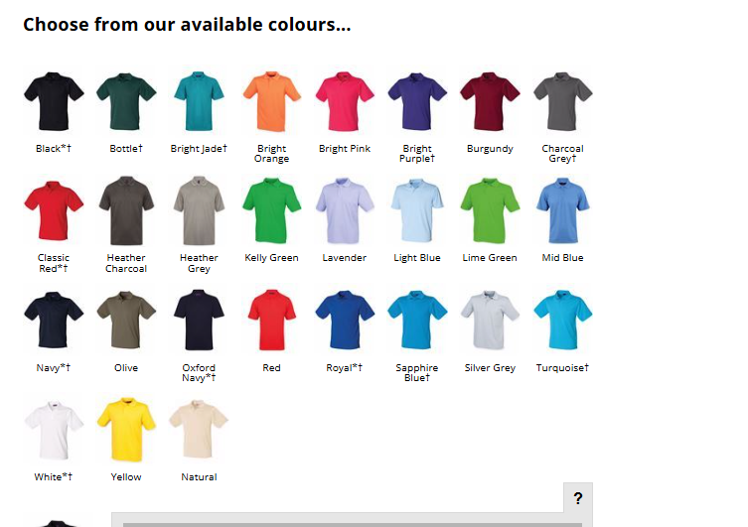

Ladies polo shirts - £14.99 including the logo – order reference H476

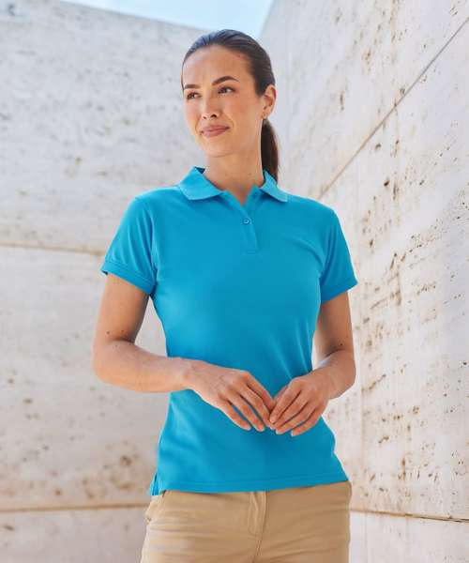
HB476: Women's Coolplus® polo shirt
Manufacturer Code: H476
The ultimate performance polo. Stay cool and fresh in this permanent wicking polo shirt. With a wide variety of colours to choose from and its ability to perform, you can be sure this polo shirt will suit all your needs.
Fabric
100% Polyester micro piqué
Weight
180gsm
Specification
Women’s Coolplus® wicking polo shirt. Micro piqué. Fitted shape. Flat knit collar. Cuffed sleeves. Side vents for ease of movement. Wicking yarn for prolonged performance. Excellent colour retention. Minimum iron. Easycare.
Washing Instructions
40 synthetic. Do not bleach. Low tumble dry. 1 dot iron. Do not dry clean. Wash at 40 degrees synthetic cycle. Can be washed up to 60 degrees. Wash dark colours separately. Do not use Fabric Softner. Tumble dry Low Temperature. Cool iron on reverse.
Sizes:XS 8 S 10 M 12 L 14 XL 16 2XL 18 3XL 20

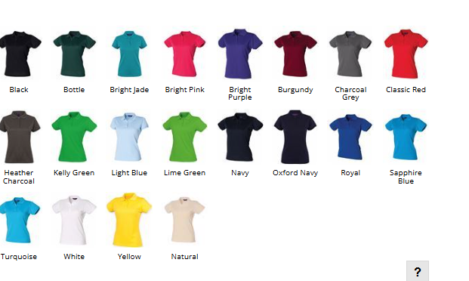

Men’s T-shirts - £8.99 including the logo

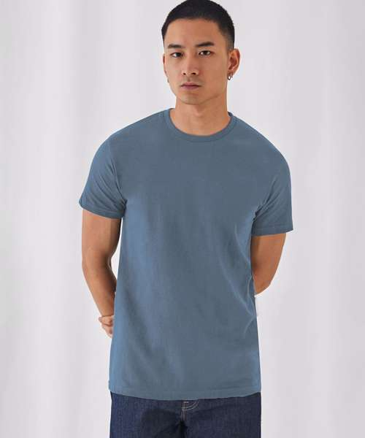Order reference BA220
100% COTTON T-SHIRT EMBROIDERED 1 POSITION: £8.99
Description
The modern basic tubular short sleeve t-shirt with contemporary look and the unchanged 190g fabric quality for 20 years. Your best choice basic tee
· Unchanged proven quality fabric
· Middle weight fabric 190gsm
· Smooth and even surface for bright and crisp printing
Fabric Type: 100% Pre-shrunk ringspun cotton
Weight: 185gsm
Sizes Available: XS 34/36" S 36/38" M 38/40" L 41/42" XL 43/44" 2XL 45/47" 3XL 49/51" 4XL* 52/54" 5XL* 53/55"
Features: *4XL and 5XL only available in these colours

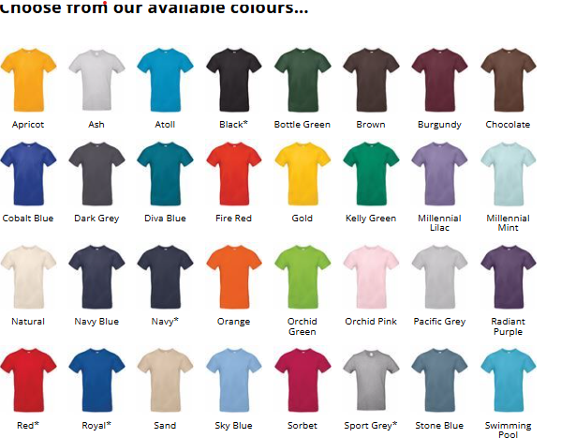

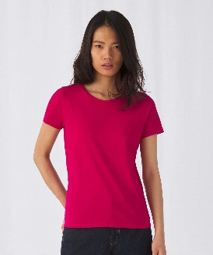Women’s 100% COTTON T-SHIRT EMBROIDERED 1 POSITION: £8.99 order reference B220F

Description
The modern basic tubular short sleeve t-shirt with contemporary look and the unchanged 190g fabric quality for 20 years. Your best choice basic tee
· Unchanged proven quality fabric
· Middle weight fabric 190gsm
· Smooth and even surface for bright and crisp printing
Fabric Type: 100% Pre-shrunk ringspun cotton
Weight: 185gsm
Sizes Available: XS 8 S 10 M 12 L 14 XL 16 2XL 18 3XL* 20
Features: *3XL only available in these colours

Colours Available
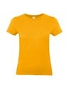  Apricot | 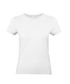  Ash | 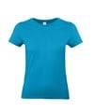  Atoll | 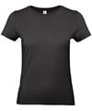  Black* | 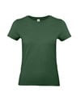  Bottle Green
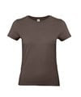  Brown | 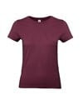  Burgundy | 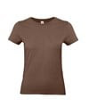  Chocolate | 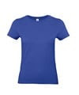  Cobalt Blue | 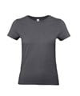  Dark Grey
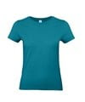  Diva Blue | 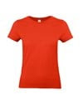  Fire Red | 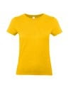  Gold | 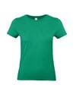  Kelly Green | 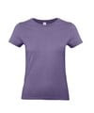  Millennial Lilac
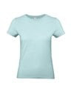  Millennial Mint | 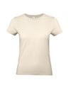  Natural | 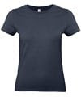  Navy* | 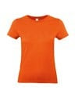  Orange | 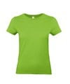  Orchid Green
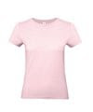  Orchid Pink | 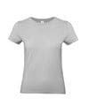  Pacific Grey | 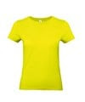  Pixel Lime | 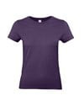  Radiant Purple | 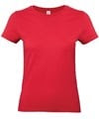  Red*
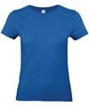  Royal Blue* | 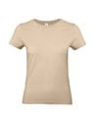  Sand | 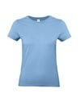  Sky Blue | 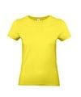  Solar Yellow | 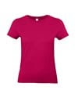  Sorbet
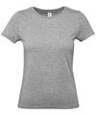  Sport Grey* | 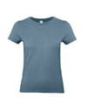  Stone Blue | 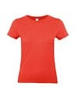  Sunset Orange | 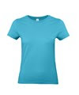  Swimming Pool | 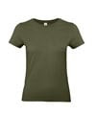  Urban Khaki
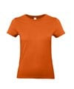  Urban Orange | 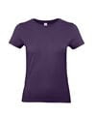  Urban Purple | 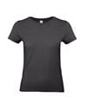  Used Black | 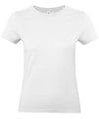  White*

  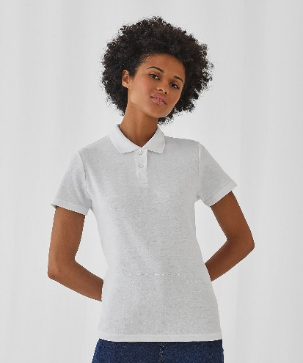
  Women’s 100% POLO T-SHIRT EMBROIDERED 1 POSITION: £11.99 order reference B306F
  Description
  The 100% cotton piqué short-sleeved polo shirt designed and engineered to offer the right style. Made of 100% pre-shrunk ringspun cotton piqué, the polo shirt features a 1x1 rib knitted collar and 2-button reinforced placket.
  · 1x1 rib knitted collar
  · Reinforced 2-button placket
  · Neck tape and side seams
  Fabric Type: Piqué, 100% Pre-shrunk ringspun cotton. Heather Grey: 90% Pre-shrunk ringspun combed cotton, 10% Viscose
  Weight: 180gsm
  Sizes Available: XS 8 S 10 M 12 L 14 XL 16 2XL 18 3XL 20

Colours Available
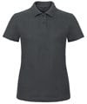  Anthracite | 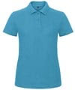  Atoll | 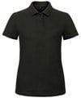  Black | 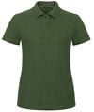  Bottle Green | 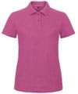  Fuchsia
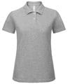  Heather Grey | 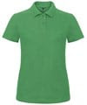  Kelly Green | 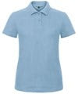  Light Blue | 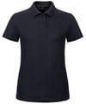  Navy | 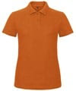  Orange
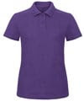  Purple | 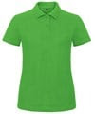  Real Green | 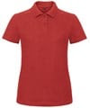  Red | 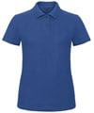  Royal Blue | 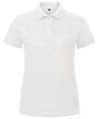  White

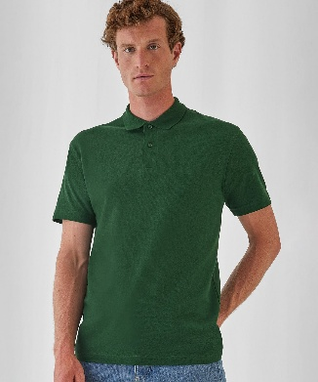 100 % Men’s Cotton polo shirt – order reference BA306
Manufacturer Code: PUI10
Basic by B&C - The 100% cotton piqué short-sleeved polo shirt designed and engineered to offer the right style. Made of 100% pre-shrunk ringspun cotton piqué, the B&C ID.001 polo shirt features a 1x1 rib knitted collar and 2-button reinforced placket. For the Perfect duo, pair it with the B&C ID.001 /women.
Fabric
Piqué, 100% Pre-shrunk ringspun cotton. Heather Grey: 90% Pre-shrunk ringspun combed cotton, 10% Viscose
Weight
180gsm
Specification
Short sleeved polo shirt. 1x1 rib flat knitted collar. Reinforced placket with 2 matching colour buttons.
Washing Instructions
Wash - 40. No - bleach. Dryer. Iron - 2. No - dry clean
Sizes:XS 34/36" S 36/38" M 38/40" L 41/42" XL 43/44" 2XL 45/47" 3XL 47/49" 4XL 49/51"

