RSCDS BANFFSHIRE BRANCH
CLOTHING CATALOGUE

RSCDS BANFFSHIRE BRANCH LOGO 1 (sample)
RSCDS ‘Ladies of Banffshire LOGO 2 (sample)

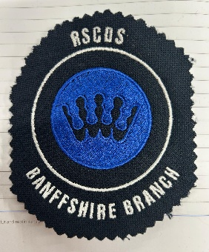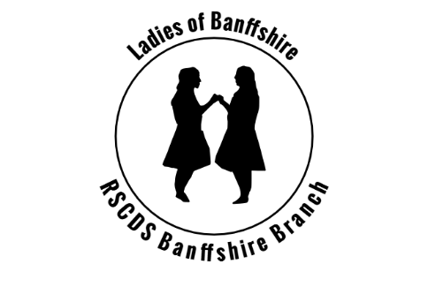

To order

- Select item of clothing
- Size
- Colour
- Logo
- Email banffshirewebsiterscdsbanffshi@gmail.com
- Include your name and dance class for delivery of your order

To pay by BACS
Sort code: 80 06 66
Account Number 00471060

If you require further information or help regarding your order, please contact our Secretary on rscdsbanffshire@gmail.com

Men’s polo shirt - £14.99 including the logo
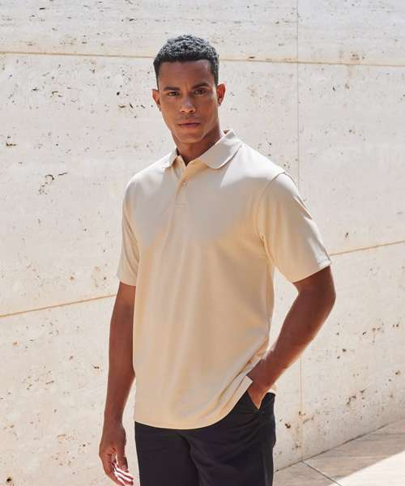
HB475: Coolplus® polo shirt
Manufacturer Code: H475
The ultimate performance polo. Stay cool and fresh in this permanent wicking polo shirt. With a wide variety of colours to chhose from and its ability to perform, you can be sure this polo shirt will suit all your needs.
Fabric
100% Polyester micro piqué
Weight
180gsm
Specification
Men’s CoolPlus® wicking polo shirt. Micro piqué. Flat knit collar. Hemmed sleeves. Side vents for ease of movement. Wicking yarn for prolonged performance. Excellent colour retention. Minimum iron. Easycare.
Washing Instructions
40 synthetic. Do not bleach. Low tumble dry. 1 dot iron. Do not dry clean. Wash at 40 degrees synthetic cycle. Can be washed up to 60 degrees. Wash dark colours separately. Do not use Fabric Softner. Tumble dry Low Temperature. Cool iron on reverse.
Sizes:XXS* 32/34" XS 34/36" S 36/38" M 38/40" L 42" XL 44/46" 2XL 48" 3XL 50/52" 4XL† 54" 5XL† 56/58"
*XXS only available in these colours. †4XL and 5XL only available in these colours

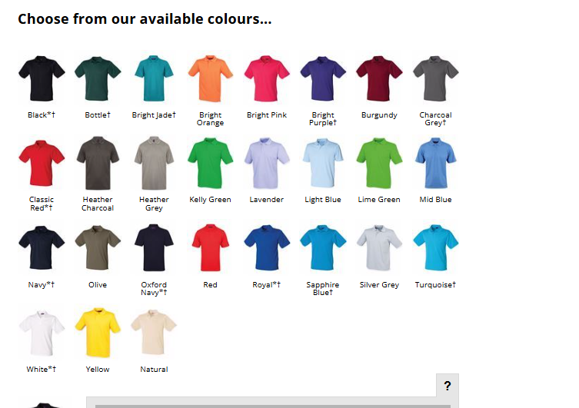

Ladies polo shirts - £14.99 including the logo

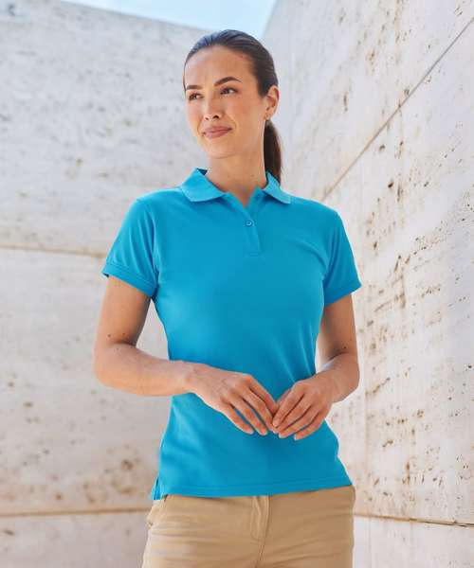
HB476: Women's Coolplus® polo shirt
Manufacturer Code: H476
The ultimate performance polo. Stay cool and fresh in this permanent wicking polo shirt. With a wide variety of colours to choose from and its ability to perform, you can be sure this polo shirt will suit all your needs.
Fabric
100% Polyester micro piqué
Weight
180gsm
Specification
Women’s Coolplus® wicking polo shirt. Micro piqué. Fitted shape. Flat knit collar. Cuffed sleeves. Side vents for ease of movement. Wicking yarn for prolonged performance. Excellent colour retention. Minimum iron. Easycare.
Washing Instructions
40 synthetic. Do not bleach. Low tumble dry. 1 dot iron. Do not dry clean. Wash at 40 degrees synthetic cycle. Can be washed up to 60 degrees. Wash dark colours separately. Do not use Fabric Softner. Tumble dry Low Temperature. Cool iron on reverse.
Sizes:XS 8 S 10 M 12 L 14 XL 16 2XL 18 3XL 20

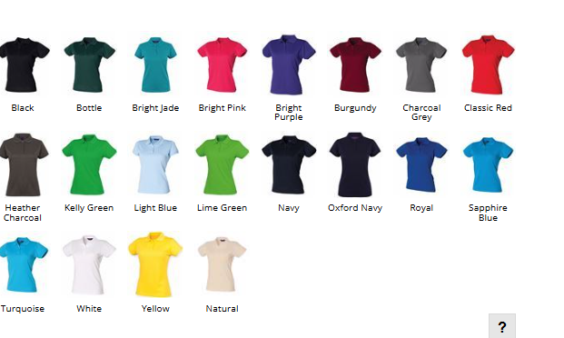

Unisex Tshirts - £7.99 including the logo

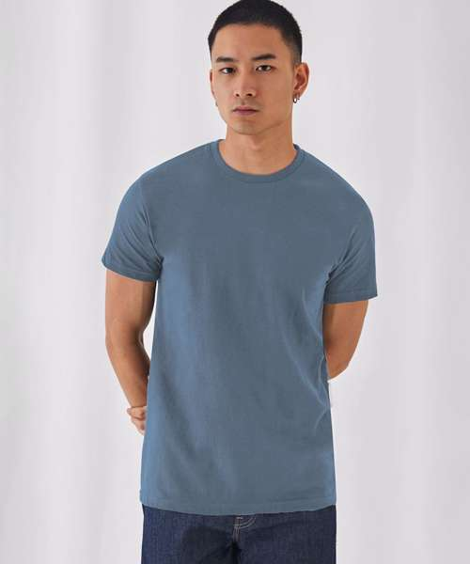

BA220: B&C #E190
Manufacturer Code: TU03T
The modern basic tubular short sleeve t-shirt with contemporary look and the unchanged 190g fabric quality by B&C for 20 years. Your #190bestchoice #basictee
Fabric
100% Pre-shrunk ringspun cotton
Weight
185gsm
Specification
Mainstream contemporary fit. Tubular construction. Thin collar rib for modern appearance. Back necktape for a clean finish. 9 sizes - XS to 5XL. Satin label. Made of 100% cotton. Resistant fabric and soft handfeel. Unchanged proven B&C quality fabric. Middle weight fabric 190 gsm Very smooth and even surface for bright and crisp printing results #details. Tested and approved for all standard printing techniques applicable on cotton Folded in box to ease the decoration process.
Washing Instructions
Wash-40, no-bleach, dryer, iron-2, no-dry clean.
Sizes:XS 34/36" S 36/38" M 38/40" L 41/42" XL 43/44" 2XL 45/47" 3XL 49/51" 4XL* 52/54" 5XL* 53/55"
*4XL and 5XL only available in these colours

