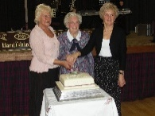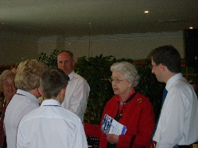**RSCDS Banffshire Branch – Established in 1929**

**Introduction**

Originally formed as the Buckie and District Scottish Country Dance Society at a Public meeting in Buckie on Monday 9th September 1929, the title was changed to the Banffshire Branch at the first Annual General Meeting.  
Those initial classes in Buckie soon spread when our first Dance Teacher, Mr John Duncan, accompanied by Miss Nen Watson and Mrs Jean Mair, taught classes at Forglen, Marnoch and Cornhill.  
  
The tradition has continued for the past 95 plus years.   
We welcome new members of all ages and abilities   
  
RSCDS Banffshire encourages Scottish Country Dancing throughout the historic county of Banffshire, and its surrounding area of North East Scotland. The Branch has 37 members, including certified RSCDS teachers and CTI Instructors who teach locally, nationally, and internationally. The Branch holds an annual dance on the second Friday in November. There are also **day schools**,**dance festivals,**  special **demonstrations,** and **support for local schools with Scottish** **Country Dancing**. Local class groups also host end-of-term and annual dances, inviting other dancers to join.

The Branch organise events yearly which are as follows:

* **Classes with a Difference** were introduced a few years ago to engage members and dancers who do not usually attend social events. These classes aim to explore new dances, formations, 12-bar phrasing, and various other elements. The Teachers who take the classes are all experienced teachers who can share stories about the devisers and when formations were introduced. Lot of ‘Tales to be Told’.
* This year the Branch is holding **6 ‘Classes with a Difference’** starting in September 2025. With the launch of the new book 54 one of the classes will be based on this.

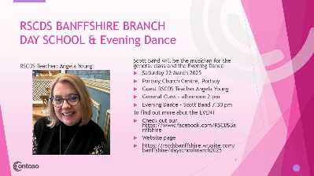

**Day School – Day of Dance**

**The Banffshire Branch of the RSCDS was delighted to welcome dancers to the Portsoy Church Centre on Saturday 22nd March for a dance workshop and an evening dance. It is over a decade since the Branch had run a day of dance, and the committee wondered if people would turn out. They need not have worried as over 50 people came through the door at 2pm for a wonderful afternoon of dancing. The teacher was Angela Young from Perthshire but really an Aberdeen Quine and the musician was Scott Band from Kirriemuir. The class was varied with all ages, even two youngsters, and all levels of experience, teachers to beginners.**

**The Branch was delighted with the event and plan to continue with a bi annual event of this nature.**

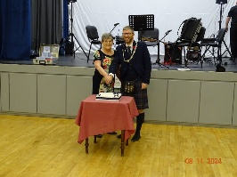

Our annual dance is held in **November** with alternating venues to ensure that all members and dancers from the widely spread geographical area is easily accessible for all.

***Photograph – Alice Archibald, Chair 24/2025 along with Gary Coull, RSCDS Chair***

* **Marketing/Promotional materialsA black shoes on a table with a few papers

  AI-generated content may be incorrect.**

Over the years, the Branch had been involved in promoting and marketing Scottish Country dancing at local events. One of the largest events we promote SCD is at the Portsoy Boat Festival at the end of June each year. At the event we encourage everyone to join in the ‘Fun, Fitness and Friendship, SCD brings to everyone. The programme includes simple dances and some Ceilidh dancing to begin the event. The promotional material is handed out at the event, and we have in the past received new members joining dance classes.

* **Website/Social media**

The branch website is kept up to date so that Branch members and the wider audience can read about – ‘What we D0’ as a Branch.

All events are shared on the Branch’s Social media page – Facebook.

When events and news are shared on social media – the link to the website new page is linked to ensure that visitors are redirected to the website to find out ***‘What we Do’.***

The Branch website's member page contains branch policies, management board news, and key documents. This ensures that members can access information regarding the AGM/Constitution and any other important news that members should be made aware of. ‘Documents’ can easily get lost or deleted in ‘long winded emails and no clogging up members storage with large documents.

So far this year from **January 2025 to April 2025** we had lots to share with our members and dancing friends from

* Anne McArthur – BEM for her work and dedication to Scottish Country Dancing and for her community work.



Winter School 2025 at Pitlochry

**Members of the Banffshire Branch along with Gary Coull, chair of RSCDS and Jim Stott, Chair of the Aberdeen Branch.**

**Gordon Bulloch, Liz Bulloch, Jim Stott, Kate Strathdee, Gary Coull and the Branch’s Management Board representative Charly Candia from Buenos Aires.**

* Two men in suits and kilts

  AI-generated content may be incorrect.**Frank’s Scroll of Honour**

Frank Thomson, a local musician, has supported the Branch in many ways over the years. From composing music for our 'Children's Resources' to performing at our first outdoor events during Covid and other functions. Frank’s Scroll, SCD was written by Dr Fred Moyes to celebrate Frank receiving his ‘Scroll of Honour’ from the RSCDS at the ‘ Autumn Gathering’ in November 2024. As a Branch we decided to record his dance which is on you tube and you can find the dance on the Strathspey Server and Dance Dictionary. I am pleased to say that Frank’s Scroll has been on programmes at local dances.

* 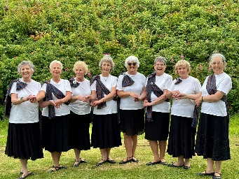**Entertaining/Demonstrations**

In August 2024, the Branch was asked to participate in celebrating Banffshire’s relations with Argentina.

**Welcome to Argentina, Aberdeenshire meets Argentina and Salinas Grandes  
were three of the dances chosen for a South American Event in the Vinery, Banff on Saturday 17th August.**This was a celebration of Banff's relationship with Argentina. José de San Martin, the liberator of  
Argentina from the Spanish met the Duke of Fife at the Battle of Waterloo. He came to Banff in  
1824 and was given the Freedom of the Burgh. This weekend celebrated the 200th anniversary of  
his visit.  
RSCDS Banffshire's link with the BASC Dancers of Buenos Aires has grown over the last five  
years with visits to Buenos Aires by Gordon, Liz and Anne and to Banffshire (Aberdeenshire) by  
Charly, Fernando and Valen.  
Long may this Aberdeenshire - Argentina connection continue.  
A second set of dances related to Banffshire: Findlater Castle; The Braes of Strathlene and The  
Hills of Alba were performed by a group of RSCDS Banffshire Ladies.

* **Care Home entertainment.**

Members of the Banffshire Branch danced at Wakefield Nursing Home on 26th February. The staff and residents gave them a warm welcome. Grace Henry, a former Branch dancer now resides there so it was a good opportunity for a catch up.

**Publications**

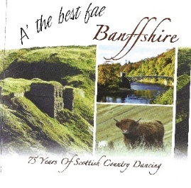The branch latest publications was the celebration of 90 Years of Scottish Country Dancing. A CD and dance book featuring dances created by members and Teachers of the Branch. The dances are popular at social function in the area.

* **Dance Classes**

The Branch is well supported by our RSCDS Teachers and CTI Instructors who run 13 dance classes in and around Banffshire/Moray/Aberdeenshire. Teachers encourage class members to participate in social events and ensure that the dances on the programs are taught locally.

***FIND A CLASS NEAR YOU***

**MONDAY CLASSES**[BUCKIE](https://rscdsbanffshire.wixsite.com/banffshire/buckiescdclass)   
​MACDUFF

**TUESDAY CLASSES**DUFFTOWN   
MILTONDUFF

MOSSTODLOCH  
TURRIFF   
 **WEDNESDAY CLASSES**FOCHABERS   
HUNTLY   
MULBEN   
 **THURSDAY CLASSES**FORGLEN, TURRIFF   
KEITH   
SPEY BAY   
 **FRIDAY (afternoon class)**FRASERBURGH   
Scan the QR Code for further information regarding venues, dates Scottish Country Dance classes near you

**Or email** [**rscdsbanffshire@gmail.com**](mailto:rscdsbanffshire@gmail.com)

* **Community events**

With our links via Anne McArthur in Portsoy we are often asked to provide Scottish Country Dancing at local events. As well as the Portsoy Boat Festival, this year we are supporting the 75th Portsoy Club and the Portsoy Thirft shop celebrating 50 years and 25 years at a community afternoon tea dance. Frank Thomson , musician will be on hand providing the music for the afternoon. Frank is very versatile and will have music for all ages for everyone to sing along to and get their feet tapping and Anne will have a programme fit for everyone to join in the fun of Scottish Country Dancing.

**Membership**

To find all about becoming a member of the RSCDS

Please visit

<https://rscds.org/get-involved/membership>

**What’s included?**

As an **RSCDS member**, you can enjoy the following benefits:

* Our bi-annual *Scottish Country Dancer* magazine
* Regular e-Newsletters with news, interviews and stories
* 10% discount on RSCDS branded items in our online store
* Discount on selected Society events organised by the RSCDS
* Member login to the RSCDS website and access to exclusive resources
* Access to our various education and teacher training programmes
* Exclusive deals with your chosen Branch*
* Receive customised information from your Branch, relevant to your local area*

Support Scottish Country Dancing in your community and join your local Branch.

Annual membership fees vary dependent on the Branch.

Visit the Banffshire Branch [website page – Membership](https://rscdsbanffshire.wixsite.com/banffshire/rscdsbanffshirecommitteemembership) details and costs involved.

<https://rscdsbanffshire.wixsite.com/banffshire/rscdsbanffshirecommitteemembership>

To visit our website page :

<https://rscdsbanffshire.wixsite.com/banffshire>

Scan the QR code

RSCDS BANFFSHIRE BRANCH

SOCIAL MEDIA PAGE

<https://www.facebook.com/RSCDSBanffshire>

For more information – contact

Branch Secretary email [rscdsbanffshire@gmail.com](mailto:rscdsbanffshire@gmail.com)

To find out about RSCDS membership visit

The RSCDS

<https://rscds.org>

RSCDS Banffshire Branch

You Tube Channel

Link here

**Some random photographs taken from events 2024/2025**

