RSCDS BANFFSHIRE BRANCH LOGO 1 (sample)
RSCDS ‘Ladies of Banffshire LOGO 2 (sample)

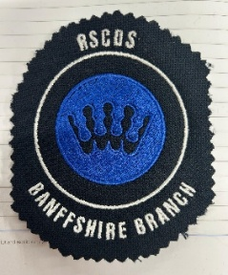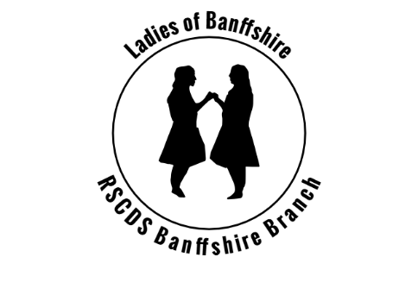

- Logo 1 Banffshire Branch (with the RSCDS crown) is embroidery and can only be selected for front left on clothing
- Logo 2. Ladies of Banffshire – choice of print on back of clothing – or embroidered on front left
- If in doubt email our Secretary or speak to one of the committee/Teachers at your dance class
Item of clothing | Size | Colour/Logo choice | Amount | Cost
Women’s polo shirt 100% Cotton  Order reference B306F |  |  |  | £11.99
Women’s polo shirt Coolplus  Order reference HB476 |  |  |  | £14.99
Women’s T-shirt 100% Cotton  Order reference B220F |  |  |  | £8.99
Men’s Coolplus poloshirt  Order reference HB475 |  |  |  | £14.99
Men’s 100% Cotton Polo shirt – order reference BA306 |  |  |  | £11.99
Men’s 100% cotton T-shirt – order reference BA220 |  |  |  | £8.99
 | Total ordered |  |  | Amount paid
Total ordered
Amount to pay
Name

Email address
Dance class attended
Orders can also be placed by emailing the required information to rscdsbanffshire@gmail.com

